

**Airport Security Pick Up**

Business Requirements Document

# 

# Version and Approvals

**UTORS**

|  |  |
| --- | --- |
| **Version History** | |
| **Version #** | **Date** | | **Revised By** | **Reason for change** |
|  |  | |  |  |
|  |  | |  |  |
|  |  | |  |  |
|  |  | |  |  |

This document has been approved as the official Business Requirements Document for Airport Security Pick Up, and accurately reflects the current understanding of business requirements. Following approval of this document, requirement changes will be governed by the project’s change management process, including impact analysis, appropriate reviews, and approvals.

|  |  |
| --- | --- |
| **Document Approvals** | |
| **Approver Name** | **Project Role** | | **Signature/Electronic Approval** | **Date** |
|  |  | |  |  |
|  |  | |  |  |
|  |  | |  |  |
|  |  | |  |  |

**Table of Contents**

Project Details 1

Overview 1

Document Resources 1

Project Overview 2

4.1 Project Overview and Background 2

4.3 Stakeholders 2

Key Assumptions and Constraints 2

5.1 Key Assumptions and Constraints 2

Use Cases 3

Use Case Diagram 3

Use Case Narrative 4

Project Details

|  |  |
| --- | --- |
| **Project Name** | Airport Security Pick Up |
| **Project Type** | New Initiative |
| **Project Start Date** |  |
| **Project End Date** |  |
| **Project Sponsor** | Customer |
| **Primary Driver** | (e.g. Mandatory or Efficiency) |
| **Secondary Driver** |  |
| **Division** |  |
| **Project Manager/Dept** | Team 2 |

Overview

This document defines the high-level requirements of Airport Security Pick Up project. It will be used as the basis for the following activities:

* Creating solution designs
* Developing test plans, test scripts, and test cases
* Determining project completion
* Assessing project success

Document Resources

| **Name** | **Business Unit** | **Role** |
| --- | --- | --- |
| Owner |  | Sponsor |
| Project Manager | IT Department | Making sure everything is going fine. |
| Team Members | IT Department | Creating the project. |
|  |  |  |
|  |  |  |

## 

Project Overview

## 4.1 Project Overview and Background

This project allows airport customers, who cannot get through TSA due to the carrying of restricted items, to be able to ship said items by using our services.

## 4.2 Stakeholders

The following comprises the internal and external stakeholders whose requirements are represented by this document:

|  | **Stakeholders** |
| --- | --- |
| 1. | Owner/Sponsor |
| 2. | Project Manager/ Team |
| 3. | Customer |

Key Assumptions and Constraints

## 5.1 Key Assumptions and Constraints

|  |  |
| --- | --- |
| **#** | **Assumptions** |
|  | Keep track of customers. |
|  | Keep track of airport where items are being held or shipped from. |
|  | Description or picture of the item. |
|  | Explanation of what is being done or needs to be done with the item. |
|  | Shipping service. |
|  | Confirmation and tracking number. |
| **#** | **Constraints** |
|  | Helping customers with shipping restricted items. |
|  | Making sure is easier for them to ship their items. |
|  | Security. |
|  | Giving customers opportunity to tack their items. |
|  | Storing the items. |
|  |  |

Use Cases

## 

## Use Case Diagram

|  |  |  |  |
| --- | --- | --- | --- |
| Use Case ID: | 1 | | |
| Use Case Name: | Airport Security Pick Up | | |
| Created By: | Team 2 | Last Updated By: |  |
| Date Created: |  | Date Last Updated: |  |

|  |  |
| --- | --- |
| Actors: | User, admin, kiosk clerk |
| Description: | Shipping restricted items |
| Preconditions: | Web browser opened, and interactive shipping web accessed. |
| Post conditions: | User navigates from interactive shipping web site. |
| Normal Course: | 1. Open browser. 2. Navigate to Airport Security Pick Up website. 3. Interact with the website using available functionality. |
| Alternative Courses: | None |
| Exceptions: |  |
| Includes: |  |
| Priority: | High |
| Frequency of Use: |  |
| Business Rules |  |
| Special Requirements: | * 24/7 access * Response times comparable to common shipping Webpages. |
| Assumptions: |  |
| Notes and Issues: |  |
| admin.PNG  clerk.PNG  Use Case Graphic: user1.PNG | |

3 Tier Architecture – Server (Heroku cloud), Browser, Database (MongoDB AWS cloud)

MongoDB AWS pricing

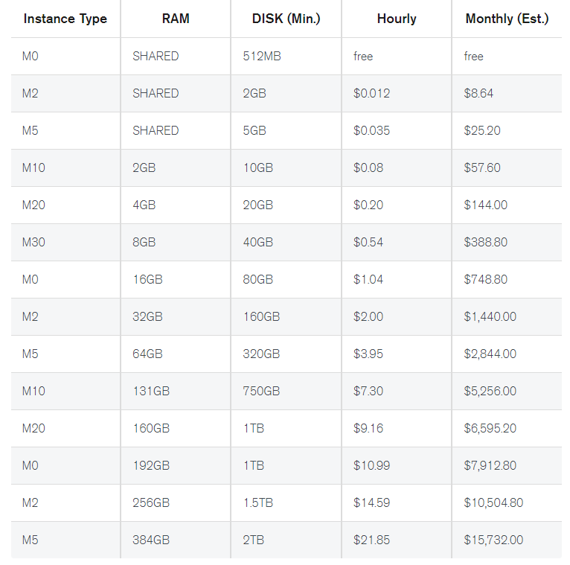

Heroku Pricing:

